**Module (HTML-5) – 3**

**Q:1:** **What Are The New Tags Added In HTML 5?**

**Ans:** There Is Added HTML 5 tags added in This details.

<header>

<footer>

<nav>

<section>

<article>

<aside>

<video>

<audio>

**Q:2 How to embed audio and video in webpage?**

**Ans: Embed audio tag:-** You can use the <Audio> tag to embed audio file in to your webpage. Here an Example.

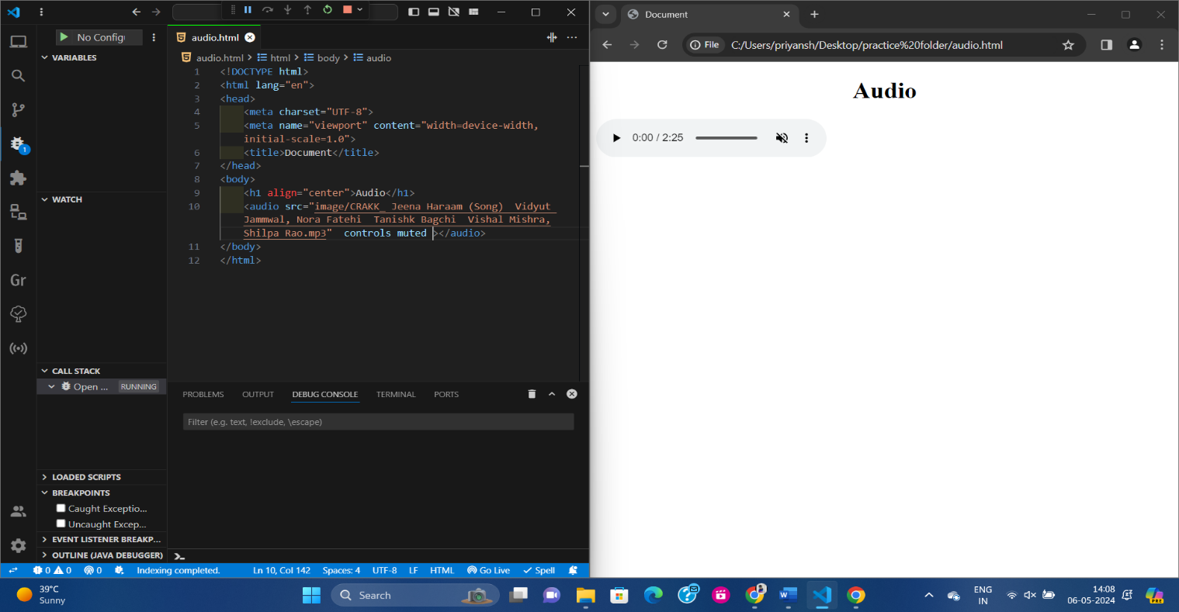**Example:-**

**Embed Video tad:-** Similarly you can use the <video> tag to embed video files into your web page. Here the example.

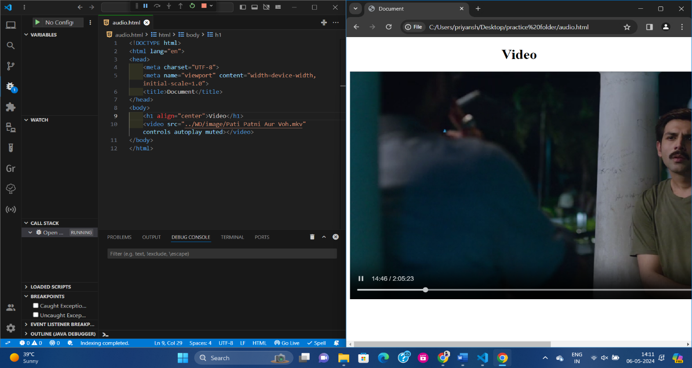**Example:-**

Q:3: **Semantic Element in HTML 5?**

**Ans:** In HTML5, using semantic elements we can make a webpage more structured. Some semantic elements include header, nav, main, article, section, aside, footer etc. It also helps in understanding the content of a webpage and searching web content.

**Q:4: Canvas and SVG tags?**

**Ans:** Canvas and SVG tags are both elements used in HTML5 to create web graphics.

The .Canvas tag is used to create raster based graphics. Using JavaScript, you can direct graphical rendering and create pictures, shapes, and other graphical images.

The .SVG tag is used to create vector-based graphics. Using an XML base, you can direct the content and create images, shapes, and other graphical images on the webpage.